# E-commerce Platform: Modules and Data Structure Justification

## Description of Modules

### User Management

This module handles user registration, retrieval, and profile management.   
 It ensures that user information is stored efficiently and can be accessed quickly using unique user IDs.

### Product Management

This module manages product information, including product IDs, names, and prices.   
 It allows adding new products to the catalog and retrieving product details.

### Browsing and Purchase History Tracker

This module tracks user interactions with products. Browsing history records the products a user has viewed,   
 while purchase history logs the products a user has bought. It provides data for analysis to generate recommendations.

### Recommendation Engine

This module analyzes browsing and purchase history to identify patterns and relationships between products and users.   
 It generates personalized product recommendations to enhance the user experience.

## Justification of Data Structures Used

### Hash Table

Used for both User and Product Management.

-Hash table allows us to get data quickly as we want ,insertion of data and deletions by using unique keys such as user IDs and product IDs.   
 They are ideal for managing a large dataset efficiently when quick access is required.

### Linked List (History Nodes)

Used for Browsing and Purchase History Tracking.  
 - Justification: Linked lists are dynamic in nature, allowing efficient addition of new nodes to track browsing and purchase events.   
 They are suitable for maintaining sequences of interactions for individual users.

### Graph (Future Enhancement)

Can be used in the Recommendation Engine to model relationships between products based on co-occurrence in browsing or purchase history.  
 - Justification: Graphs are non-linear data structures that represent relationships between entities. They are ideal for identifying patterns in complex datasets, such as identifying frequently co-browsed or co-purchased products.

Output:  
Entering User details and product details

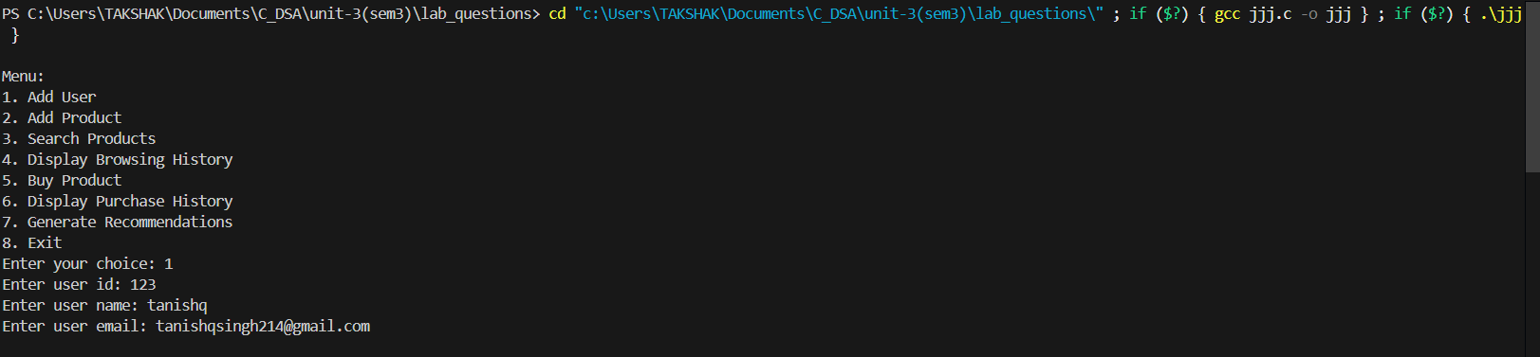

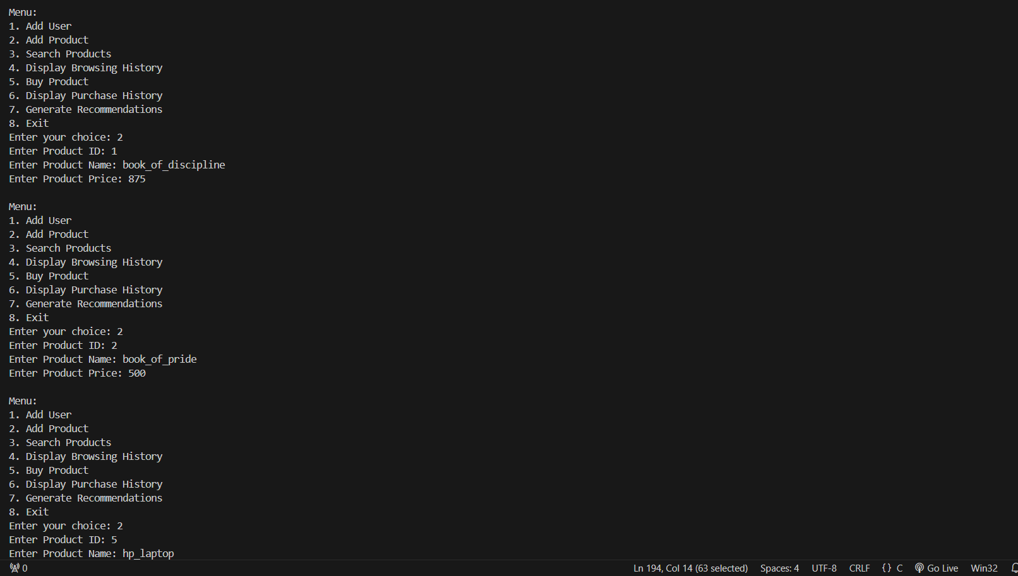

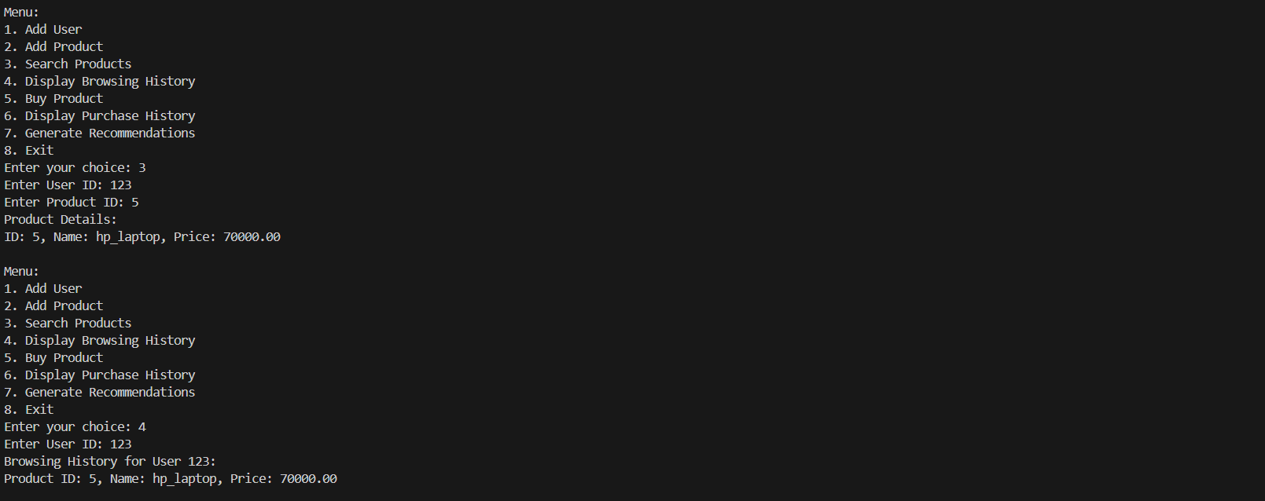

Buying a Product:

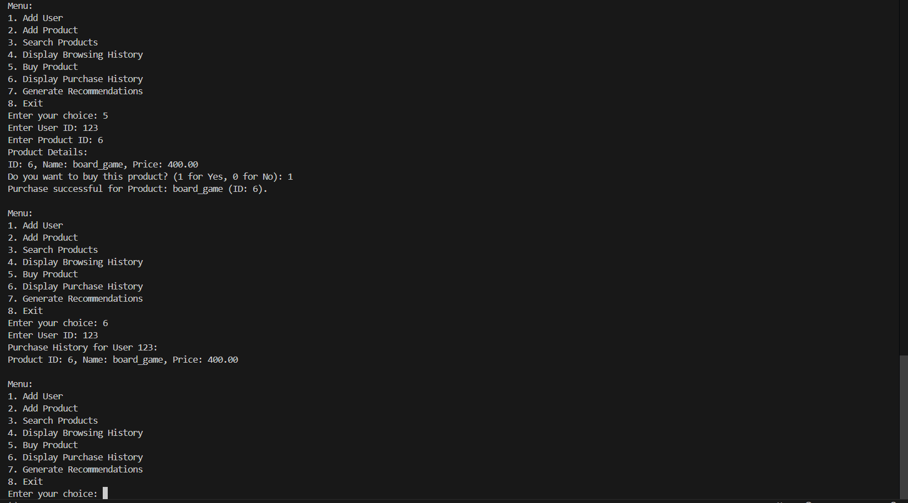

Generating Recommendation

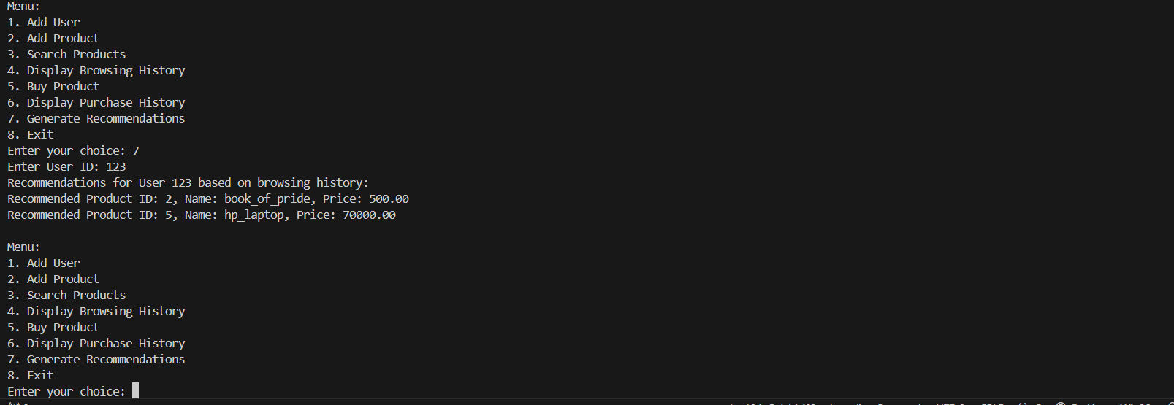

Invalid Output:

